Streaming/Media Production

PC

Niyam

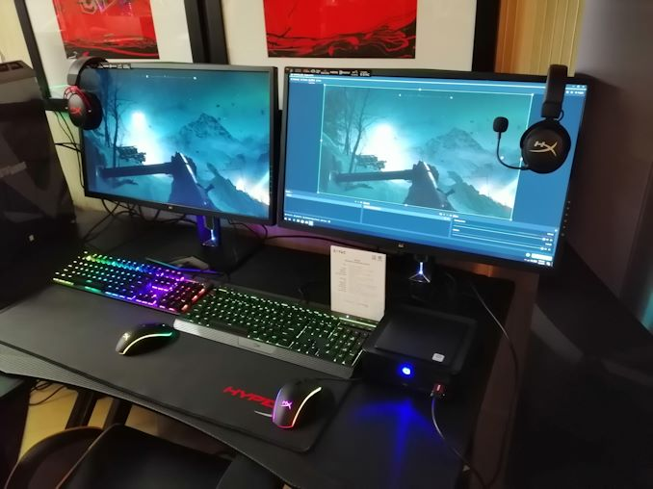

Topic: Media Production/Streaming

This trade is a trade which works on streaming games towards the internet and then proceeding to edit the full stream down to a few minutes or creating custom videos and uploading them online.

What what a good PC for streaming/media production in general terms?

For a streaming PC you need high end specs (good CPU, graphics card, RAM speed/space, Hard drive, etc.). This is so you can produce high quality of videos and good quality streams (you also need good internet for fast uploads and low latency streaming if you want 720-1080p)

The three most important parts for a streaming/media production are the CPU, GPU and Hard Disk Drive.

* The CPU must be a very good one, as the media production programs (such as photoshop and premiere pro) use a good amount of CPU to both edit a video/image and then encoding and exporting the video takes even more CPU, meaning a good CPU could accelerate the process, plus it helps with recording and streaming.
* The GPU can be used to accelerate using GPU acceleration in order to produce media quicker, if you are using it for streaming, it’s very good to use a GPU for graphics when playing games
* Hard Disk Drive is important due to computers requiring you to advocate space for media, if you do not have enough space, the media you created could save incorrectly or not be able to be saved at all, the recommended amount to avoid this is at least 1TB.

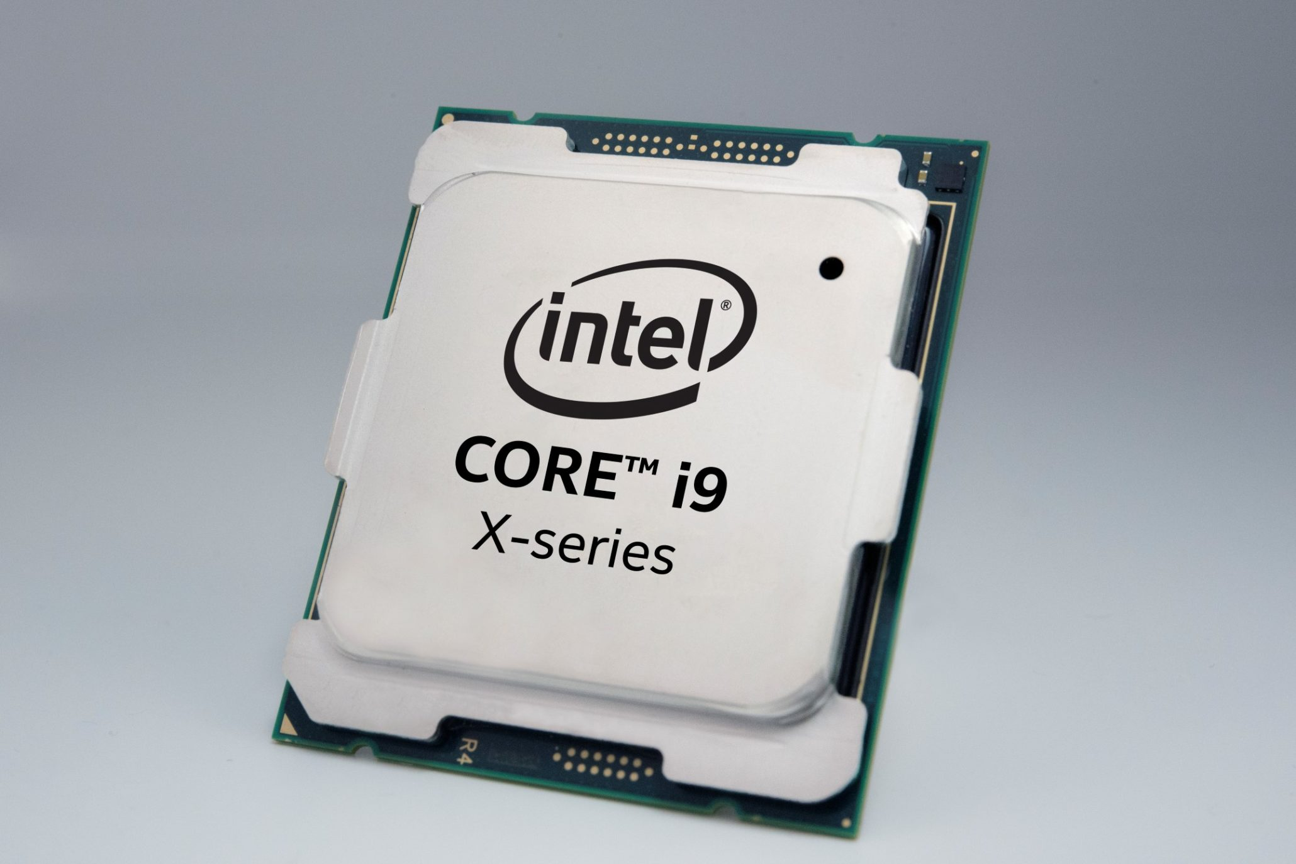

3 Components that would be nice.

* A good keyboard, mouse and monitor would be nice, but not necessary
* Good portibility would be nice, but not very necessary
* A soundcard is a good for high quality sounds, but can be easily replaced with a good pair of headphones

**[Estimated Wattage: 416W](https://pcpartpicker.com/list/#)**

|  |  |  |  |  |  |  |  |  |  |  |  |  |
| --- | --- | --- | --- | --- | --- | --- | --- | --- | --- | --- | --- | --- |
| Component |  | Selection | | Base | Promo | Shipping | Tax |  | Price | Where |  |  |
| [**CPU**](https://pcpartpicker.com/products/cpu/) |  |  | [**Intel Xeon E5-4620 2.2 GHz 8-Core Processor**](https://pcpartpicker.com/product/xdZQzy/intel-cpu-bx80621e54620) | **$76.78** |  |  |  |  | [**$76.78**](https://pcpartpicker.com/mr/amazon/xdZQzy) |  | [**Buy**](https://pcpartpicker.com/mr/amazon/xdZQzy) |  |
| [**CPU Cooler**](https://pcpartpicker.com/products/cpu-cooler/) |  |  | [**Corsair H100i RGB PLATINUM SE 63 CFM Liquid CPU Cooler**](https://pcpartpicker.com/product/XzDJ7P/corsair-h100i-rgb-platinum-se-63-cfm-liquid-cpu-cooler-cw-9060042-ww) | **$155.99** |  | **FREE** |  |  | [**$155.99**](https://pcpartpicker.com/mr/bestbuy/XzDJ7P) |  | [**Buy**](https://pcpartpicker.com/mr/bestbuy/XzDJ7P) |  |
| [**Motherboard**](https://pcpartpicker.com/products/motherboard/) |  |  | [**Supermicro X9SRH-7TF ATX LGA2011 Motherboard**](https://pcpartpicker.com/product/tCgPxr/supermicro-x9srh-7tf-atx-lga2011-motherboard-x9srh-7tf) | **$514.99** |  | **$5.99** |  |  | [**$520.98**](https://pcpartpicker.com/mr/superbiiz/tCgPxr) |  | [**Buy**](https://pcpartpicker.com/mr/superbiiz/tCgPxr) |  |
| [**Memory**](https://pcpartpicker.com/products/memory/) |  |  | [**G.Skill Ripjaws Series 8 GB (2 x 4 GB) DDR3-1066 Memory**](https://pcpartpicker.com/product/RjxfrH/gskill-memory-f38500cl7d8gbrl) | **$40.99** |  | **FREE** |  |  | [**$40.99**](https://pcpartpicker.com/mr/newegg/RjxfrH) |  | [**Buy**](https://pcpartpicker.com/mr/newegg/RjxfrH) |  |
| [**Memory**](https://pcpartpicker.com/products/memory/) |  |  | [**G.Skill Ripjaws Series 8 GB (2 x 4 GB) DDR3-1066 Memory**](https://pcpartpicker.com/product/RjxfrH/gskill-memory-f38500cl7d8gbrl) | **$40.99** |  | **FREE** |  |  | [**$40.99**](https://pcpartpicker.com/mr/newegg/RjxfrH) |  | [**Buy**](https://pcpartpicker.com/mr/newegg/RjxfrH) |  |
| [**Memory**](https://pcpartpicker.com/products/memory/) |  |  | [**G.Skill Ripjaws Series 8 GB (2 x 4 GB) DDR3-1066 Memory**](https://pcpartpicker.com/product/RjxfrH/gskill-memory-f38500cl7d8gbrl) | **$40.99** |  | **FREE** |  |  | [**$40.99**](https://pcpartpicker.com/mr/newegg/RjxfrH) |  | [**Buy**](https://pcpartpicker.com/mr/newegg/RjxfrH) |  |
| [**Memory**](https://pcpartpicker.com/products/memory/) |  |  | [**G.Skill Ripjaws Series 8 GB (2 x 4 GB) DDR3-1066 Memory**](https://pcpartpicker.com/product/RjxfrH/gskill-memory-f38500cl7d8gbrl) | **$40.99** |  | **FREE** |  |  | [**$40.99**](https://pcpartpicker.com/mr/newegg/RjxfrH) |  | [**Buy**](https://pcpartpicker.com/mr/newegg/RjxfrH) |  |
|  |  | [**Add Additional Memory**](https://pcpartpicker.com/products/memory/) | | | | | | | | | | |
| [**Storage**](https://pcpartpicker.com/products/internal-hard-drive/) |  |  | [**Seagate Barracuda Compute 2 TB 3.5" 7200RPM Internal Hard Drive**](https://pcpartpicker.com/product/mwrYcf/seagate-barracuda-computer-2-tb-35-7200rpm-internal-hard-drive-st2000dm008) | **$54.89** |  | **FREE** |  |  | [**$54.89**](https://pcpartpicker.com/mr/outletpc/mwrYcf) |  | [**Buy**](https://pcpartpicker.com/mr/outletpc/mwrYcf) |  |
| [**Storage**](https://pcpartpicker.com/products/internal-hard-drive/) |  |  | [**Seagate Barracuda Compute 2 TB 3.5" 7200RPM Internal Hard Drive**](https://pcpartpicker.com/product/mwrYcf/seagate-barracuda-computer-2-tb-35-7200rpm-internal-hard-drive-st2000dm008) | **$54.89** |  | **FREE** |  |  | [**$54.89**](https://pcpartpicker.com/mr/outletpc/mwrYcf) |  | [**Buy**](https://pcpartpicker.com/mr/outletpc/mwrYcf) |  |
|  |  | [**Add Additional Storage**](https://pcpartpicker.com/products/internal-hard-drive/) | | | | | | | | | | |
| [**Video Card**](https://pcpartpicker.com/products/video-card/) |  |  | [**Zotac GeForce RTX 2060 6 GB GAMING AMP Video Card**](https://pcpartpicker.com/product/kfWfrH/zotac-geforce-rtx-2060-6-gb-gaming-video-card-zt-t20600d-10m) | **$359.99** |  |  |  |  | [**$359.99**](https://pcpartpicker.com/mr/amazon/kfWfrH) |  | [**Buy**](https://pcpartpicker.com/mr/amazon/kfWfrH) |  |
| [**Case**](https://pcpartpicker.com/products/case/) |  |  | [**Anidees AI Crystal Cube MAR 3 ATX Mid Tower Case**](https://pcpartpicker.com/product/v4n8TW/anidees-ai-crystal-cube-mar-3-atx-mid-tower-case-ai-cl-cube-mar3) | **$169.90** |  | **FREE** |  |  | [**$169.90**](https://pcpartpicker.com/mr/amazon/v4n8TW) |  | [**Buy**](https://pcpartpicker.com/mr/amazon/v4n8TW) |  |
| [**Power Supply**](https://pcpartpicker.com/products/power-supply/) |  |  | [**Thermaltake Toughpower GF1 ARGB 850 W 80+ Gold Certified Fully Modular ATX Power Supply**](https://pcpartpicker.com/product/PTBhP6/thermaltake-toughpower-gf1-argb-850-w-80-gold-certified-fully-modular-atx-power-supply-ps-tpd-0850f3fagu-1) | **$189.99** |  | **$4.49** |  |  | [**$194.48**](https://pcpartpicker.com/mr/amazon/PTBhP6) |  | [**Buy**](https://pcpartpicker.com/mr/amazon/PTBhP6) |  |
| [**Optical Drive**](https://pcpartpicker.com/products/optical-drive/) |  | [**Choose An Optical Drive**](https://pcpartpicker.com/products/optical-drive/) | | | | | | | | | | |
| [**Operating System**](https://pcpartpicker.com/products/os/) |  |  | [**Microsoft Windows 10 Home OEM 64-bit**](https://pcpartpicker.com/product/wtgPxr/microsoft-os-kw900140) | **$109.89** | **-$10.00** [**1**](https://pcpartpicker.com/list/#promo_explain1) | **FREE** |  |  | [**$99.89**](https://pcpartpicker.com/mr/outletpc/wtgPxr) |  | [**Buy**](https://pcpartpicker.com/mr/outletpc/wtgPxr) |  |
| [**Software**](https://pcpartpicker.com/products/software/) |  | [**Choose Software**](https://pcpartpicker.com/products/software/) | | | | | | | | | | |
| [**Monitor**](https://pcpartpicker.com/products/monitor/) |  |  | [**MSI Optix MAG240VC 23.6" 1920x1080 144 Hz Monitor**](https://pcpartpicker.com/product/Bfzkcf/msi-optix-mag240vc-236-1920x1080-144-hz-monitor-optix-mag240vc) | **$169.99** |  |  |  |  | [**$169.99**](https://pcpartpicker.com/mr/amazon/Bfzkcf) |  | [**Buy**](https://pcpartpicker.com/mr/amazon/Bfzkcf) |  |
|  |  | [**Add Another Monitor**](https://pcpartpicker.com/products/monitor/) | | | | | | | | | | |
| [**External Storage**](https://pcpartpicker.com/products/external-hard-drive/) |  | [**Choose External Storage**](https://pcpartpicker.com/products/external-hard-drive/) | | | | | | | | | | |
|  |  |  |  |  |  |  |  |  |  |  |  |  |